

Amorphous ice Experimental Procedure

Last UPDATED: 15 / 01 / 2020

VINCENT DEGUIN / SABRINA GAERTNER

**Contents**

1. Overall Design 3

1) Glovebox (GB) 3

2) BOSH Structure: 8

2. Set up 9

1) From OU to ISIS 9

2) From the van 🡪 NIMROD Workbench 9

3) NIMROD 9

a) Material required: 9

b) Installation: 10

3. Particle production 12

1) Start-up experiment 12

2) Reaction vessel cooling 13

3) Making cryo-ethane: 15

4) Make icy particles: 15

4. Sample recovery 17

1) Start-up experiment 18

2) Cell filling 19

5. Loading CCR 20

6. Shut Down 21

**Appendix** 22

A. Temperature control 22

1) Thermocouple setup 22

2) PID loops 22

a) PID loop 1 (Eurotherm) 22

b) PID loop 2 (Lakeshore) 22

B. Gas regulators 23

C. Cooling Curve (empty Dewar) 24

D. Ethane liquefaction curve 25

E. Ethane warming curve 26

F. Parameter logging sheets 27

1) Base parameters: 27

2) Sample production: 27

G. Experimental timetable 28

# Overall Design

## Glovebox (GB)

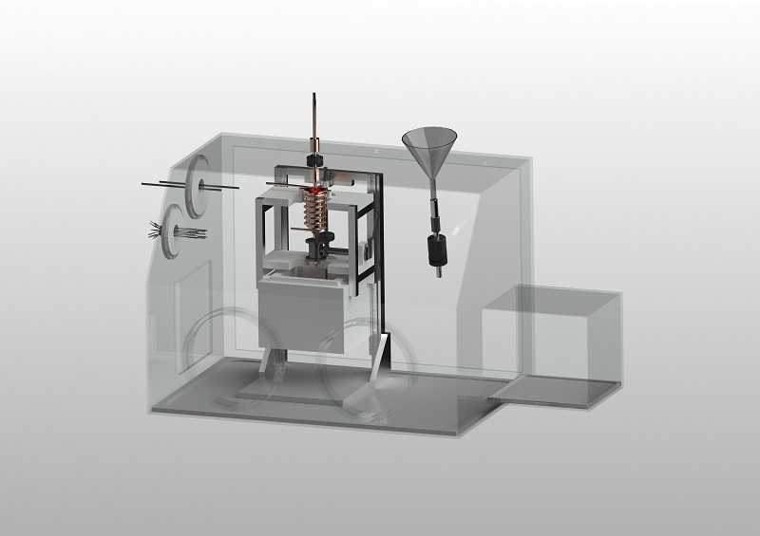

**1**

**2**

**3\***

**4**

**5**

**6**

**7**

**8**

**9**

**9**

**11**

**13\***

**10**

**12\***

**14\***

**15+ 16\***

**14`\***

**17**

**3`\***

**18\***

**# IV**

**Figure 1‑1 :** CAD model of the Glove Box (numbers explained in the text).. # indicate that the setup will be discribed in further detail in a figure later in the text.

**# II**

**# III**

Key (entries marked with an asterisk [*] are not clearly shown on CAD model above):

1. Inlet for liquid nitrogen, connected directly from pressurized vessel to bottom of fixed tubing around copper vessel [5] using ¼” steel tubing.
2. Outlet for liquid nitrogen, connecting from top of tubing around copper vessel [5] (¼” steel tubing) to exhaust (6mm PTFE tubing, rated for appropriate low temperature exposure) and directly into a Deware.

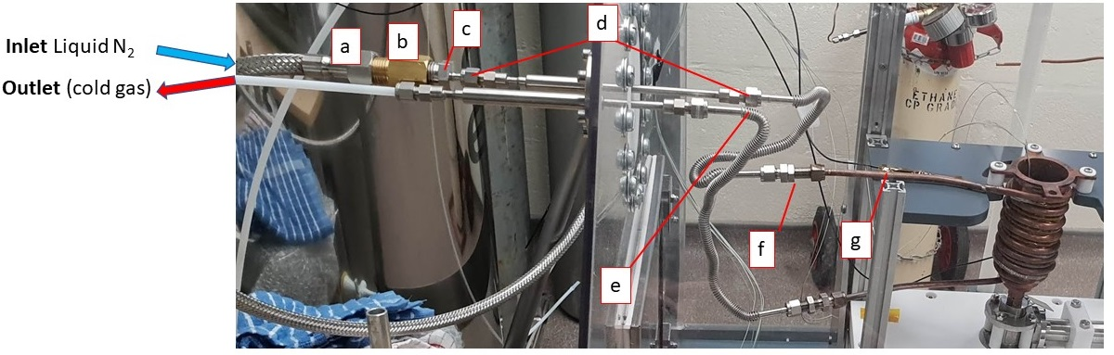

**Figure 1‑2 :** Liquid Nitrogen feedthrough CF-40 (MDC vacuum 9812105). **[a]** cryogenic hose ½“ BSP , **[b]** ½” male to female adapter, **[c]** Male tube adaptor ¼” tube OD * ½” (Swagelock SS-4-TA-1-8), **[d]** Swagelock tubing connection ¼” , **[e]** Stainless steel flexible tubing ¼” OD (Swagelock 321-4-X-12-B2), **[f]** Bulkhead union ¼” OD (Swagelock SS400-61), **[g]** Copper tubing ¼” OD,

The flange is made of a 1 cm thick PTFE disk, to isolate the polycarbonate wall of the glove box from the cold nitrogen temperatures.

**3\*** Outflow to exhaust for gases within glove box (6mm plastic tubing/fitting directly mounted on glove box wall), connected to vent line via Legris 6 mm Polymer banking plug (RS 0722053). 3` is the equivalent for the airlock chamber

**4** Thermocouple feedthrough (6 * T type). ATEX certified (Ex II 2 GD, Ex d IIC Gb / Ex e IIC Gb, Ex ta IIIC Da) product for explosive atmosphere.

* For thermocouple installation see **Appendix A**

**5** Reaction vessel with integrated tubing around outer wall (silver soldered). Temperature controllable with fitted heating wire (40 V) and liquid nitrogen flow through tubing to achieve approximately 90K, allowing for (a) ethane liquification and (b) amorphous ice formation.

**6** Valve attaching to base of reaction vessel [5]. Rated for operation with cryogenic materials/environments.

**7** Release point for material in copper vessel [5] when valve [6] is opened.

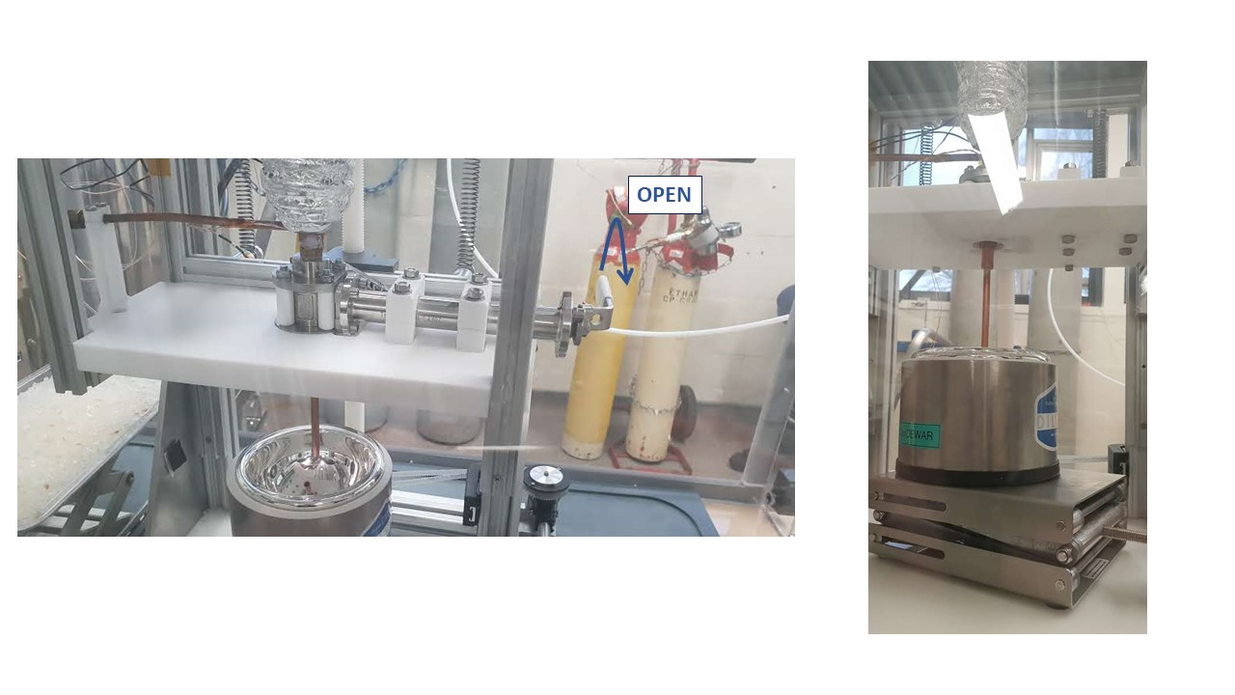

Figure ‑ : Valve [6] and sample recovery setup

**8** Collection cell for amorphous ice particles (cf sample recovery p17), self-contained in a Polystyrene-walled box (not indicated in figure 1-3).

**9** Glove ports. Suitable gloves (butadyl, antistatic) for use with glove box are fitted to these ports and sealed with steel jubilee clips/hose clamps.

**10** Funnel port. Valve at base of funnel isolates this port from the inside of the chamber during normal operation. It can be opened to allow addition of liquids, e.g. small amounts of liquid nitrogen to a Deware if/as required. Could also serve as back-up for pressure-relief-valve.

**11** Airlock chamber for introducing or removing material from the Glovebox. This is constantly purged by N2 via inlet 14` from N2 bottle1 (cf figure 2-1) and exhausted through port 3` to the vent line via Legris 6 mm Polymer banking plug (cf 3*).

**12\*** Valve inlet for ethane (gas). Connected from and ethane cylinder secured within the lab, via a flammable gas regulator and flashback arrestor, to a tube line which can be repositioned to move the end away from/position it above copper vessel [5] for ethane liquefaction.

**13\*** Over-pressure gauge, 0 – 1.6 bar, monitoring pressure of atmosphere within glove box. At normal running conditions (slight overpressure), no reading from the gauge is expected.

**14\*** Nitrogen gas inlet, mounted directly onto wall of glove box and connecting through 6 mm plastic tubing to N2 bottle1 (cf figure 2-1). Connects from a nitrogen cylinder secured within the lab. Line features an overpressure release valve, calibrated using gauge [13].

**15*+16\*** Nebulizer inlet. Reservoir of deionized water and/or D2O connects though this port, pressure is provided by dedicated nitrogen cylinder secured in lab to deliver water into copper vessel [5] as a fine mist through the nebulizer.

**17** Nebulizer heater. Prevents water freezing in nebulizer and/or line from water reservoir. Controlled via PID controller and attached thermocouples.

**18\*** Proportional Low pressure Relief Valve (Swagelock SS-RL3S4-EP) connected to vent line via Legris 6 mm Polymer banking plug (cf 3*). Calibrated in-house at 0.2 bar. Triggering should not be expected at normal operating conditions.

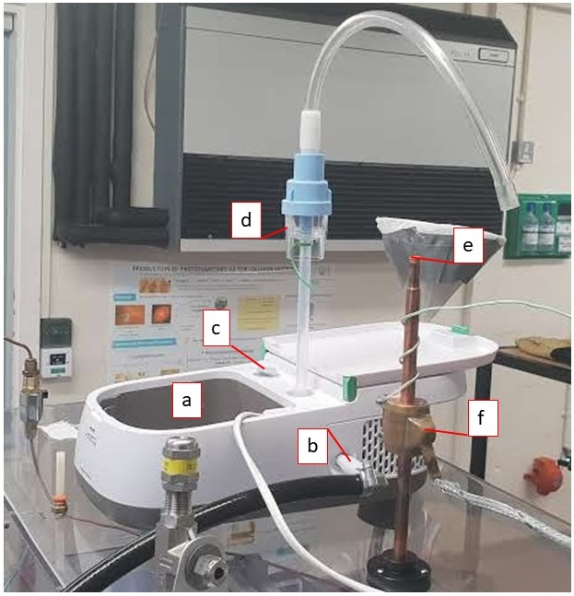

Figure 1‑4 : Nebulizer setup [a] Nebulizer (Philips Innospire), [b] N2 Inlet gas connection (from N2 bottle 2 cf fig 2-1), [c] Switch on button, [d] Water reservoir, [e] Nozzle plug, [f] Heating ring

**NB :** Feedthroughs (1, 2, 4) are machined from PTFE blocks to prevent thermal shocks from temperature gradients between glovebox walls and lN2 lines.

## BOSH Structure:

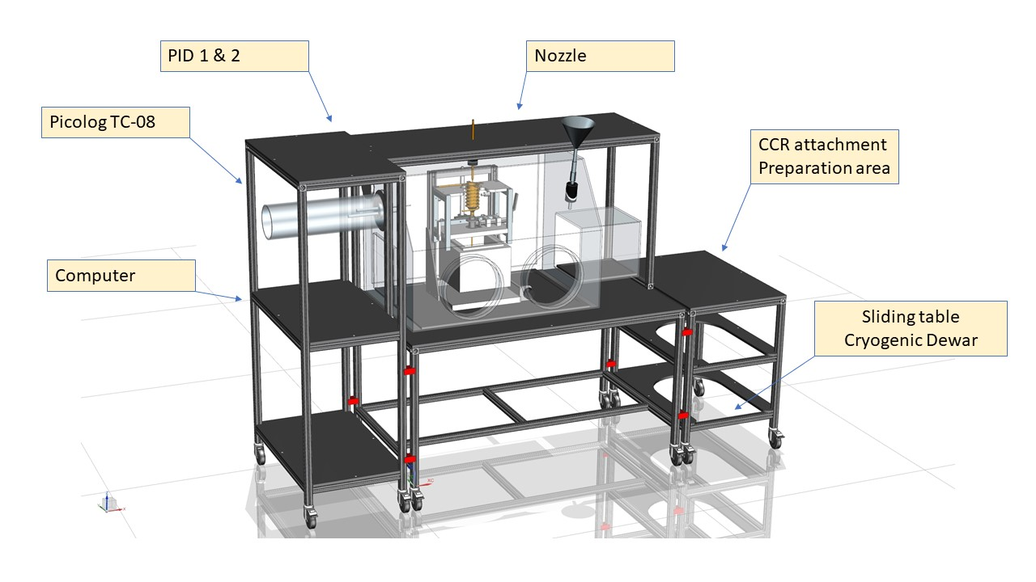

Figure ‑ : BOSH structure (22 / 12 / 2019) 🡪 Will be updated

# Set up

## From OU to ISIS

* Remove all equipment from inside GB
* Wheel GB into the Van
* Secure in place

## From the van 🡪 NIMROD Workbench

* Wheel the GB out of the van
* Bring in TS2 Hall in a safe and secured place
* Crane GB onto NIMROD Workbench

## NIMROD

### Material required:

* 3 N2 cylinder (1 zero grade, 2 Industrial)
  + Bottle 1: N2 GB purging
  + Bottle 2: Nebulizer carrier gas
  + Bottle 3: Full bottle to interchange in case of runout
* 1 Ethane cylinder
* 1 liquid N2 pressurized Dewar, 200L, to be installed in the NIMROD sample prep area and attached to GB
* Cryogenic hose (1m or 2m)
* Pipe tubing (PTFE 1/4” OD)
* Manifold (1/4” push through fittings) 🡪 Legris 6 mm Polymer banking plug (RS 0722053)

### Installation:

Figure ‑ : Working space organisation. LN2 Dewar should be placed on the left side of the Glove box.The gas bottle (respectively N2 1,2,3 and the ethane cylinder) should be place behind while allowing free movment at the rear of the Glove box

* Connect inlet 14 to N2 bottle 1 regulator using PTFE ¼” piping. Secure gas fitting on bottle 1 with jubilee clip
* Connect bottle 2 to Nebulizer
* Ensure those connections are tight and leak tested
* Connect cryogenic hose to Fill valve of Liquid N2 Dewar
* Attach (a) to (b) and (b) to (c) as refereed in figure 1-2
* Insert in liquid N2 Flange (d) and screw firmly in place
* Implement PTFE 1/4” inch pipe (2-3 m) on the flange Outlet
* Put Reaction vessel inside GB
* Connect corrugated pipes (e) to flange (inside GB)
* Then, connect corrugated pipes to reaction vessel (g) through connection (f)
* Insert nozzle at desired height
* Attach and screw heating ring around nozzle copper block
* Connect heater input to PID
* Place thermocouples as indicated in **Annex A,** and tape with kapton
* Ensure they are also attached to the main structure to reduce mechanical stress.

# Particle production

## Start-up experiment

* Add all the materials which need to go inside GB:  
  + Frost shield
  + Q-tip (Clear condensation/freezing at the end of nozzle)
  + Paper sheet (monitor water flux within GB)
  + Towel
  + Tweezers (*2) to handle cold materials
  + Cryo-Gloves
* Turn on computer
* Turn on Lakeshore PID, Eurotherm and check Input parameters are correct
* Check placement, integrity and functionality of thermocouples
* Check and record all experimental base parameter (cf Appendix D)
* Close the port at the rear of the glove box (2 persons needed)
* Screw firmly in place using screw driver
* Turn on N2 flow to main glove box [14] (0.2 Bar)
* Allow time for nitrogen flow to remove air from glove box (60 mins)

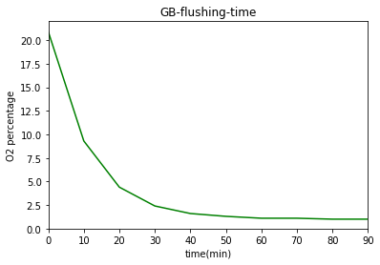

Figure ‑ : Percentage of Oxygen within the glove box with respect to time during flushing (0.2 bar N2 flow)

O*2* level (60 min) = 1.1 % (Ethane lower flammability limit = 3%)

* Reduce N2 flow below 0.1 Bar to maintain a slight overpressure and a comfortable working environment.
* Ensure that pressure reading on gauge [13] is 0.

## Reaction vessel cooling

* Check that pipe outlet [2] is inserted in a Dewar.
* Open Labview 🡪 *“Program name”*
* Start Labview Temperature recording program (time = 0)

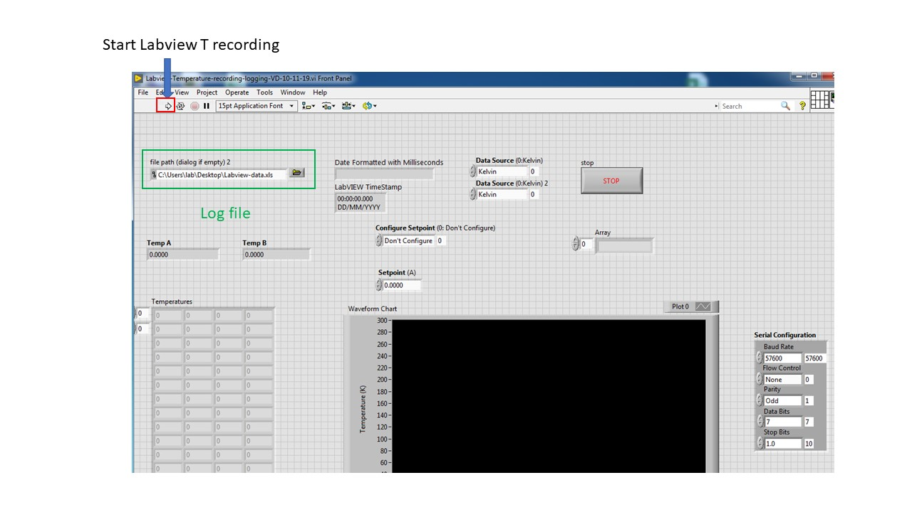

Figure ‑ : Labview interface (to be updated, 08-01-20)

* 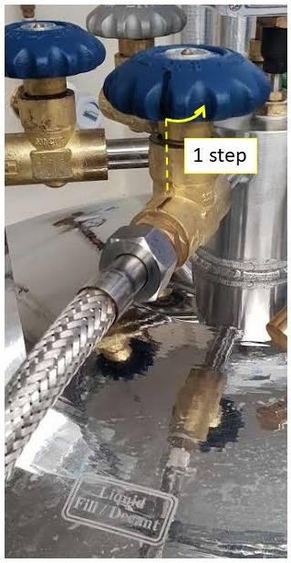(time = 1 min) Open fill valve on liquid nitrogen vessel to begin coolant flow [1 → 5 → 2]

Figure ‑: Deware - hose connection

* When copper vessel [5] has cooled (<10 min cf **Appendix C**) to base temperature, activate PID controller attached to heater on this vessel and set temperature to desired range. Allow time (few minutes) for this value to stabilize.
* Check that the cooling matches reference curve (Appendix C)

## Ethane liquefaction:

* Clean ethane line by purging with a small amount of ethane gas: slightly open, then close in this order: ethane bottle, regulator, valve 12
* Position ethane line [tubing in glove box from 12] over copper vessel [5]. Make sure that pipe is 1 cm deep inside reaction vessel and that it is not in contact with the copper wall.
* Move Dewar up and down to adjust pipe position
* Open valve at top of ethane cylinder
* Slowly increase the pressure on the regulator`s outlet to 80 mbar.
* Open ethane inlet valve [12] and observe ethane liquefaction
* Heater temperature at copper vessel [5] can be adjusted using PID controller [attached to 4] to encourage ethane liquefaction
* When enough liquid ethane formed (liquid level 2cm to the top 🡪 230 cm3), close the valve at the top of the ethane cylinder and drain out volume between bottle and regulator to stop flow
* Wait a few seconds and then close ethane inlet valve [12]
* Move the ethane tube line [from 12] well away from the copper vessel [5]

## Make icy particles:

* Fill water reservoir with deionized water/D2O.
* Check temperatures:
  + T end of nozzle: stable and above 0 °C
  + T nozzle heater block below 50 °C
* Slowly introduce nitrogen pressure into the nebulizer [15+16] (0.5 bar)
* Turn on Nebulizer
* Wait few seconds (necessary to start the nebulization), then control the quality of the flux (a mist should be visible)
* Once OK, level up the Dewar to reach an equilibrium between T of the nozzle and efficiency of the water droplet insertion (1-3 cm from ethane surface)
* Remove plug (e on fig 1-4) on top of nozzle
* Connect water reservoir and copper nozzle (start timer)
* Water ice production time (20 min)
* During introduction, check that no frost is growing on nozzle (stop the introduction by disconnecting water reservoir and nozzle, put the plug in place and clean nozzle mouth with Q tip if necessary)
* Control:
  + Quality/speed of water flow: no condensation or freezing at the end of pipe)
  + level of water in nebulizer reservoir
  + level of liquid ethane.
* When enough sample produced (20 min introduction), disconnect water reservoir from nozzle
* Plug the nozzle with cork (e)
* turn off nebulizer and shut N2 gas valve

# Sample recovery

Figure 4‑‑

**1** Copper block. Use as a heat sink to control the cell temperature

**2** Liquid ethane spill-tray. Conduct the heat from the copper block to the cell and catch liquid ethane during filtration procedure.

**3** Step

**4** Vanadium foil can with 1 mm spacer referred as “sample can”.

**5** Thermocouple junction.

**6** Funnel (ISIS spacer taped by aluminum foil).

## Start-up experiment

* Fill polystyrene Dewar inside the Glove box with liquid Nitrogen through funnel 10 until Copper Block fully submerged.
* **Introducing liquid N2 within GB:**
* Open valve 10 at the base of funnel while pressing on the glove (to let pressure decrease within GB without introducing air inside)
* Close valve 10
* Pour liquid N2 into funnel (1/2 full)
* Open valve 10 (pressure should increase, and glove inflate due to lN2 evaporation)
* Press on the gloves to remove the excess pressure and clove valve 10
* Repeat as needed
* Put the precooled lid (not indicated on picture) on top of the cell to both improve the cooling and prevent frost accumulation on the cell.
* Monitor cell temperature and keep refilling the Polystyrene Dewar to maintain copper block submerged until base temperature is reached.

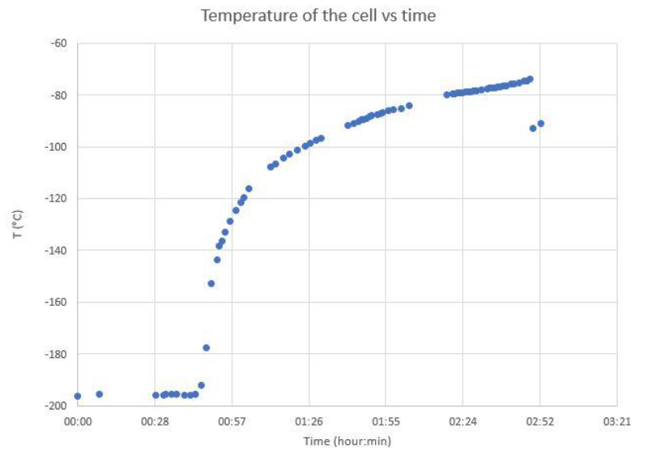

Figure ‑: Cell warming curve

* Once this is achieved, let the system warm up until T is within desired range (90 – 105 K).

## Cell filling

* Remove lid
* Open valve 6 slowly by pulling it toward you and let ethane/particles flow
* Wait until most of the ethane is drained through the loose junction between the cell and the funnel.
* Put the precooled cell cap on top of the cell.
* Screw in place and put in liquid Nitrogen Dewar.
* Move Dewar out of Glove box through airlock chamber (11).

# Loading/Unloading CCR

## Loading

* Bring small Dewar holding the cell to the instrument pit
* Bring cylindrical polystyrene Dewar filled with LN2 to instrument pit
* Take out screws from CCR lid
* Fill CCR with helium up to 1 atm
* Stop helium flow
* Freeze bottom few cm of centre stick in LN2
* Sit cell upright in LN2
* Mount cell on stick, keeping cell submerged in LN2 as much as possible
* Wrap sensor cable around stick a few times and plug in sensor on stick.
* Ensure that cable is not in the beam path
* If adjustment is required, take off copper connector and gently warm up sensor. Bending or twisting cold sensors tends to break them.
* Submerge stick with cell in LN2
* Start helium flow
* Take off CCR lid
* Transfer centre stick into CCR
* Put in screws (hand-tight)
* Purge (3 times)
* Sometimes required: 4th purge
* Fill up to desired pressure of He, usually 30 – 100 mbar

## Unloading

### If final T < 140 K

* + Transfer under LN2 to lab
  + Open cell in fume hood and allow to warm up
  + Take video of ethane evaporation to confirm ice particle amount
  + As soon as ice starts melting, flush cell with acetone

### If final T ≥ 140 K

* Transfer under LN2 to lab
* Open cell in fume hood
* Take photo of remaining ice particles
* As soon as ice starts melting, flush cell with acetone

# Shut Down and Secure GB

* Stop lN2 flow and let ethane warm up and boil slowly for 40 min (cf Appendix E)
* Check N2 flow is turned on (0.1 bar) and that enough N2 remain in bottle 1 (at least 20 bar).
* When all ethane is evaporated, Turn off N2 flow from bottle 1, open glove box and clean

# **Appendix**

# Temperature control

## Thermocouple setup

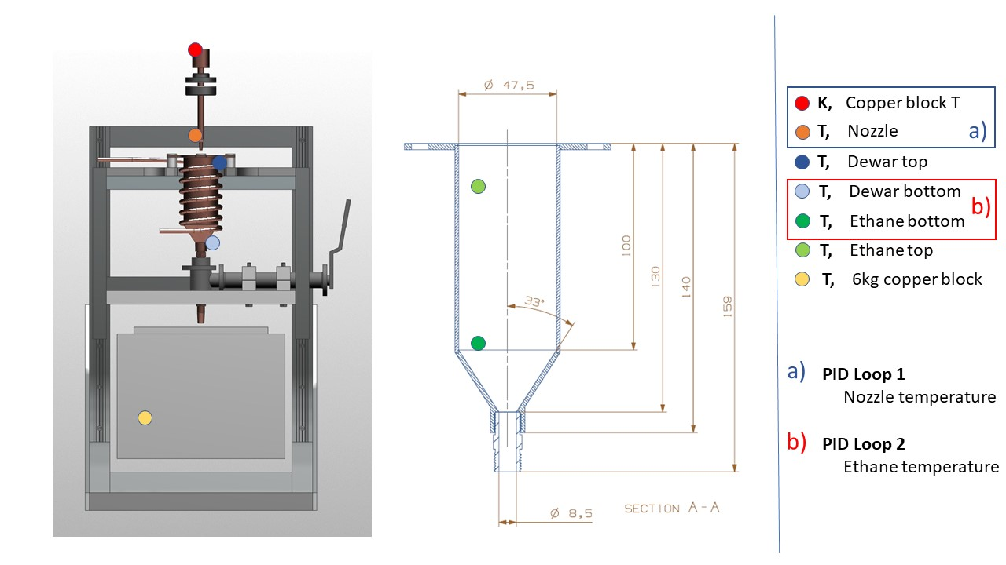

Figure ‑

## PID loops

### PID loop 1 (Eurotherm)

### PID loop 2 (Lakeshore)

# Gas regulators

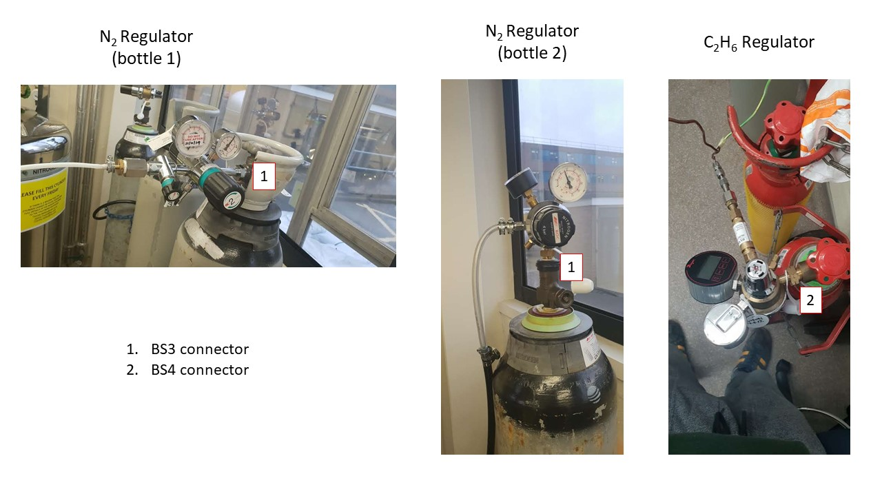

# Cooling Curve (empty Dewar)

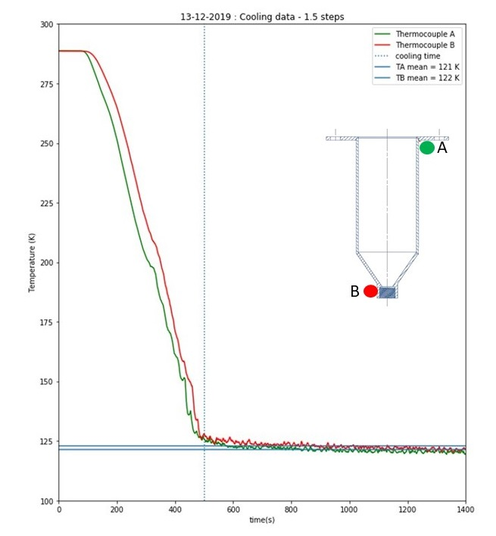

# Ethane liquefaction curve

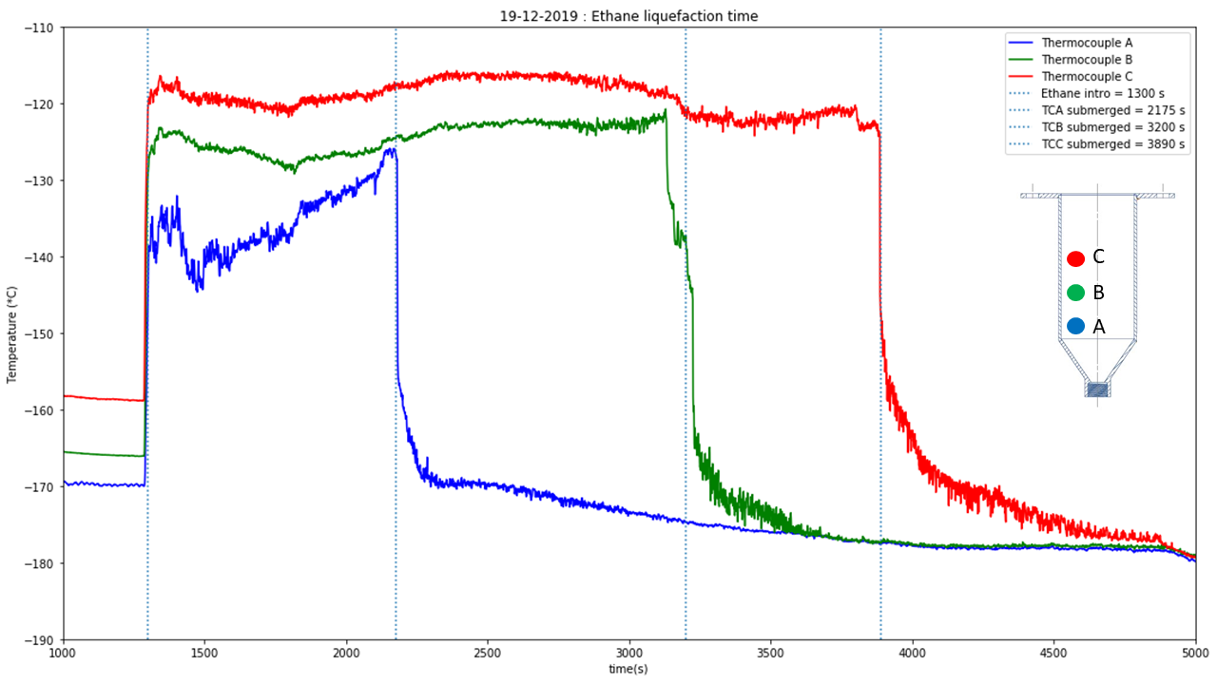

# Ethane warming curve

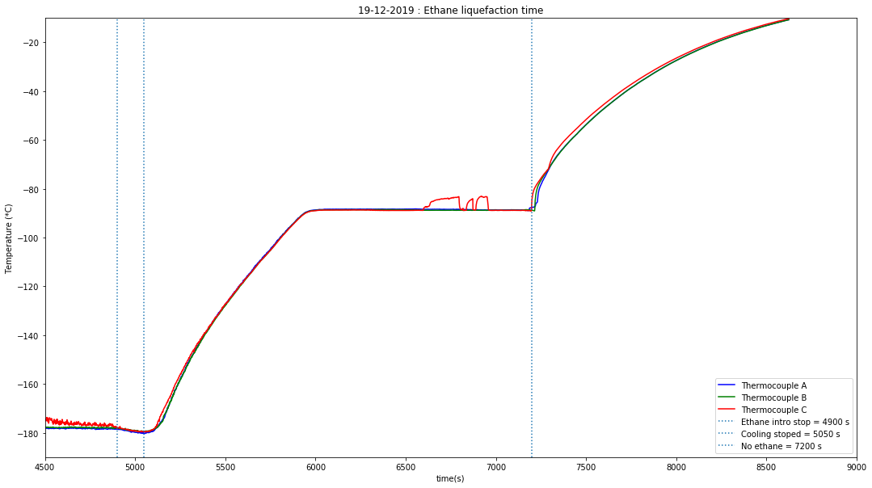

# Parameter logging sheets

## Base parameters:

## Sample production:

# Experimental timetable

